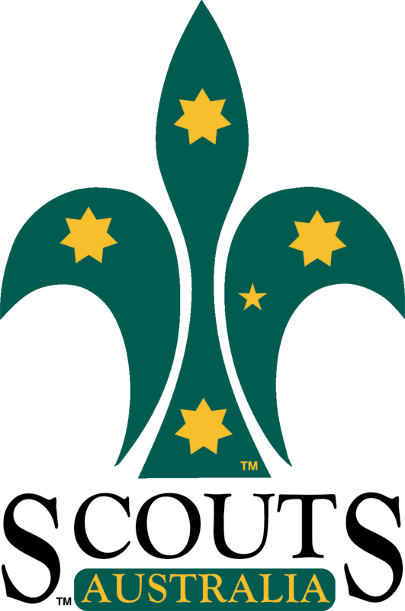
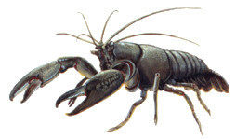
Rosanna Cubs

Yabby / BBQ Night

Next Tuesday (the 18th) we’ll be having a BBQ and Yabbying night at Binnak Park in Nth Watsonia.

Location: Binnak Park (Melway 10 D11). Closest street is Binnak Dr, between Glendalough Ct and Dunraven Ct. On some Melways, the area we’re meeting is just marked as “Play”, but there is a BBQ area and small lakes there.
Time: Tuesday 18th March, 7pm start and pickup at 8:30pm.
Food: Meat/Vegieburgers, bread, drinks etc., will be supplied for the Cubs.
Parents/Siblings: Parents/siblings are welcome, but please bring your own food to cook/eat and parents please supervise your other children.
For Yabbying: Please bring an old stocking and coat hanger if you can (to make a ‘net’) and, if you intend on being successful, a bucket (or ice-cream container and lid) to take your yabby(s) home. Yabby meat and string will be supplied.
Bring: Cubs to wear hat and uniform – wear sunscreen.

Regards

Akela (Wayne)

akela@rosannacubs.org
9434 7594

See us at www.rosannacubs.org

